# Website Project Brief

## Project Title: Creating a website to help GCSE students

##### Client Contact Details

[Enter a valid Name/ corporation]

Name of the website: StudySesh

##### budget and Timing

I’m aiming to create a website from scratch without spending any money on it. Therefore my budget will be £0.

In terms of the launch date, I’m confident that by mid-October the website will be online and fully operational.

##### Project outline

The main purpose of StudySesh is to aid GCSE students in their revision by providing resources like past papers and subject aimed notes. The website will also help students find useful material for revision such as YouTube video tutorials or other websites that might help them, by offering them a section with numerous sources linking to this materials.

The client will expect me to code a website that seems original and is attractive to young audiences (13 to 17 years old), as this website is aimed for GCSE students. He will also expect the website to have content that is relevant and interesting to teenagers, so that they are engaged to the website.

##### Exemplar websites

* 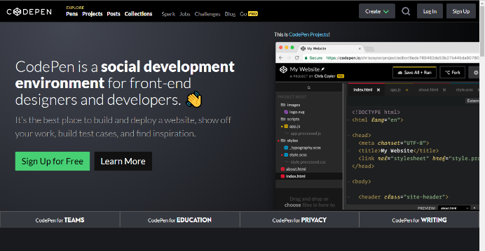Codepen is a great example of how I want my website to look like, design wise. The navigation bar is quite simple but very modern and interactive which fits with the style of website I want to create. Nevertheless, I won’t be using the dark colours that Codepen is using as they don’t suit my target audience.

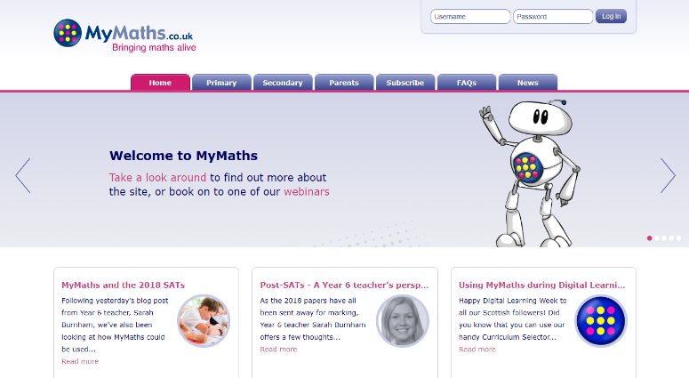

* MyMaths is a great example of how I would use neutral colours in my website. I also like the ease of navigating through the site, as all the options are displayed in the navigation bar with a proper title name that fully explains what that page is going to be about. Nevertheless, MyMaths’ website design doesn’t fit what I’m looking for in my website as it seems quite outdated and boring.

##### Website architecture

Coding languages:

- HTML5/CSS5: I will use this languages in order to create the basic layout of the website and to also produce the design for it.

- Bootstrap: I will use this language to add interactive features to my website like an image carousel. Bootstrap will also allow me to adapt the size of my website to different devices, which means that my website will be more available to users.

//Structure of the website: [Picture of the flowchart]

##### Web style and design

|  |  |
| --- | --- |
| Design Coding language | I will use CSS3 in order to style my website as it is the most advanced and efficient version of CSS and is also the general language to design websites. |
| Design | Futuristic/Modern/State-of-the-art: in order to comply with my target audience’s taste. |
| Colours | I will be using neutral colours: Red, neutral blue and black. |
| Interactive | It’s going to include interactive features such an image carousel, and interactive navigation bar. |

##### Search engines (Seo)

I will use keywords in my titles and also in my website description in order to make my site more attractive to customers when they are browsing. Having an efficient SEO will allow me to reach more people and to increase the visibility of my website.

The keywords that I’m that I will use include: GCSE, Student, Exam Papers, Exam Help, Subjects, Exams etc.

##### Connected social media

In order to reach out to my target audience I will be creating 2 different social media pages. This will be Twitter and Facebook. {Insert logos}. Social media pages will be displayed in my website as favicons that users can click on if they want to see/follow them.

Once the social media is created I will be uploading news and updates about my website, but also they will be a great tool to interact with my users and to get feedback from them.

##### Content

|  |  |
| --- | --- |
| Client | Information about the client in the about me page. |
| Information | - General exam advice for students doing their GCSEs  - Best resources/exam papers to use in order to prepare for exams |
| Interactive content | - Image carousel for users to see the latest news about exams or website updates.  - Small games for users to test their skills on.  - Links to products to amazon by using the amazon API. |
| Subject specific content | - Links to useful YouTube videos.  - Past papers and revision materials.  - Recommended material for the subject (books and equipment) |

##### monetization

In order to benefit from the creation of this website, I will need to monetize it. I will do this in a way that my audience is not negatively affected by it, which rules out ads as they are annoying for young audiences.

I decided to monetize my website by doing a non-conventional online store. In this store user will be able to see different products such as books, school equipment etc. but the users will not be able to buy it from my website. Instead, in the product information there will be a link sending them to the product in Amazon. I will do it this way so that I benefit from the Amazon Associates Program, which will give me 10% of the total price of the products the user buys from my link.

##### Competition and niche

I'm aiming to introduce my website to the niche market of GCSE material and education websites. This is a market that is very competitive in the UK. Websites like MyMaths, Student room and StudyWise are the main competition as all of them offer a wide range of GCSE material in their sites, and they also have great monetization schemes making them very versatile and efficient.

In order to make my website more competitive than the others I will have to innovate in an unique way that my target audience will be attracted to.